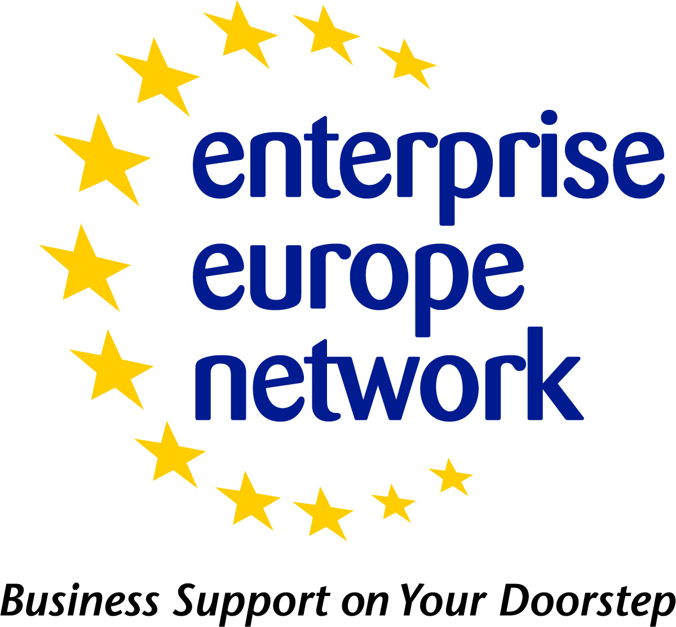 | Research Development Request - Profile Template  Updated - June 2013
 | European Commission
Research Development Request Profile
The following table can be used as a template for drafting a Research Development Request profile. Please be sure to refer to the Research Development Request Profile Guidelines for what information you should include in each field.
Please note:
- Fields that can be ticked should only have one selection when drafting the profile unless specified under the field title.
- Fields marked with asterisk (*) are mandatory
Field Title | Field To be populated
Title*
Internal Reference
Summary*
(1-500 characters)
Advantages and Innovations
(50-2000 characters)
Stage of Development* | Already on the market  Available for demonstration  Concept Stage  Field Tested / Evaluated  Project Already Started  Project in Negotiations - Urgent  Proposal under development  Prototype available for demonstration  Under development / lab tested
Comments Regarding Stage of Development

Description*
(100-4000 characters)
Technical Specification or Expertise Sought
IPR Status  Note: Multiple fields can be selected. | Copyright  Design Rights  Exclusive Rights  Granted patent or patent application essential  Other (registered design, plant variety, etc.)  Patent(s) applied for but not yet granted  Patents granted  Secret Know-how  Trade Marks
Comments Regarding IPR Status
Technology Keywords*
Market Keywords*
NACE Keywords*
Responsible* | *In Merlin, select who from your organisation will be responsible for this profile*
Sector Group | Agrofood  Automotive, transport and logistics  Bio Chem Tech  Creative Industries  Environment  Healthcare  ICT Industry and Services  Intelligent Energy  Maritime Industry and Services  Materials  Nano – and Microtechnologies  Services and Retail  Space and Aerospace  Sustainable Construction  Textile and Fashion  Tourism and Cultural Heritage  Women entrepreneurship
Restrict Dissemination to specific countries
Type and Size of Client* | Industry SME <= 10  Industry SME 11-49  Industry SME 50 – 249  Industry 250-499  Industry >500  Industry MNE >500  Inventor  Other  R&D institution  University
Year Established
Turnover (Euros – Millions) | <1M  1-10M  10-20M  20-50M  50-100M  100-250M  250-500M  >500M
Already Engaged in Trans - national Cooperation? | Yes (In Merlin tick the check box for yes)  No
Additional Comments
Certification Standards
Language Spoken
Client Country
Type and Role of Partner Sought*
Profile is Opened for Expressions of Interest? | Yes (In Merlin tick the check box for yes)  No
Type and Size of Partner Sought  Note: Multiple fields can be selected. | SME < 10  SME 11-50  SME 51 – 250  251-500  >500  MNE >500  Inventor  R&D institution  University
Type of Partnership Considered* | Research Cooperation Agreement
Framework Programme* | Access to finance  Business and innovation services  Capacities  Competitiveness and Innovation Framework Programme (CIP)  Cooperation  Coordination of Research Activities  Digital Content  Energy  Entrepreneurship and Innovation Programme  Environment (including Climate Change)  ERC  Eureka  Food, Agriculture and Fisheries, Biotechnology  Foster energy efficiency and the rational use of energy resources  Health  ICT for a low carbon economy and smart mobility  ICT for health, ageing well and inclusion  Ideas  Industry Academia  Information & Communication Technologies  Information Communication Technologies Policy Support Programme  Initial training  Innovative government and public services  Integrated initiatives  International cooperation  International dimension  Joint Technology Initiatives  Life-long training  Nanosciences, Nanotechnologies, materials and new Production  Open innovation for internet enabled services  People  Promote energy efficiency and the use of new and renewable  Promote new and renewable energy resources  Promotion of Entrepreneurship  Regions of knowledge  Research for the benefit of SMEs  Research infrastructures  Research potential of Convergence Regions  Science in society  Security  Seventh Framework Programme (FP7)  Socio-economic Sciences and Humanities  Space  Specific actions  Support to eco-innovation  Support to innovation  Support to the coherent development of research policies  The Intelligent Energy Europe Programme  Transport (including Aeronautics)
Call Name*
Evaluation Scheme*
Anticipated Project Budget
Coordinator Required | Yes (In Merlin tick the check box for yes)  No
Deadline for the Call*
Funding Scheme* | Collaborative Projects  Coordination and Support Actions  Individual projects: Support for "frontier" research  Networks of Excellence  Research for the benefit of specific groups (in particular SMEs)  Support for training and career development of researchers
Project Duration (in weeks)
Web link to the Call
Project title and acronym
Attachments | *Only can be added in Merlin*  File Size max 4Mb. Only jpg, gif and jpeg files allowed.

